1

K-Mean Centroids: [[59.53086419753087, 62.641975308641975], [77.97183098591549, 80.50704225352112]]

K-Medoid Medoid[[59, 62], [78, 81]]

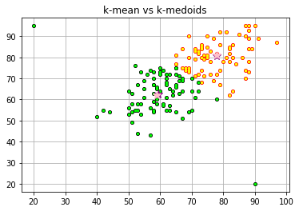

K-Medoid Score:97.04198399650362

K-Means Score:97.04198399650362

2

K-Mean Centroids: [[77.44, 80.05333333333333], [59.09090909090909, 62.15584415584416]]

K-Medoid Medoid[[60, 64], [78, 81]]

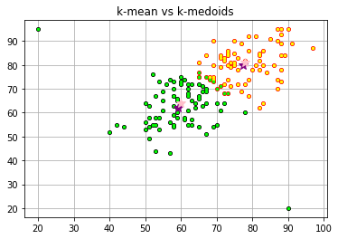

K-Medoid Score:95.68258149559504

K-Means Score:97.74999556310135

3

K-Mean Centroids: [[59.53086419753087, 62.641975308641975], [77.97183098591549, 80.50704225352112]]

K-Medoid Medoid[[60, 64], [78, 81]]

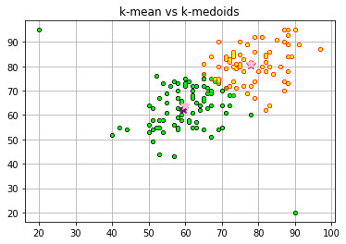

K-Medoid Score:95.68258149559504

K-Means Score:97.04198399650362

4

K-Mean Centroids: [[77.44, 80.05333333333333], [59.09090909090909, 62.15584415584416]]

K-Medoid Medoid[[82, 84], [63, 65]]

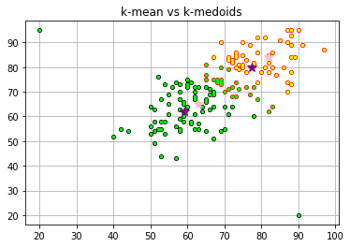

K-Medoid Score:90.00377109496556

K-Means Score:97.74999556310135

5

K-Mean Centroids: [[77.97183098591549, 80.50704225352112], [59.53086419753087, 62.641975308641975]]

K-Medoid Medoid[[59, 62], [76, 78]]

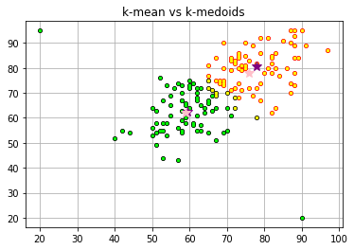

K-Medoid Score:96.536337826803

K-Means Score:97.04198399650366

6

K-Mean Centroids: [[59.53086419753087, 62.641975308641975], [77.97183098591549, 80.50704225352112]]

K-Medoid Medoid[[60, 64], [78, 81]]



K-Medoid Score:95.68258149559504

K-Means Score:97.04198399650362

7

K-Mean Centroids: [[68.0, 71.32450331125828], [90.0, 20.0]]

K-Medoid Medoid[[59, 62], [78, 81]]

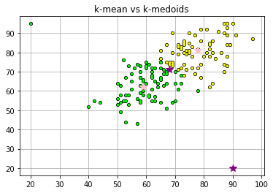

K-Medoid Score:97.04198399650362

K-Means Score:nan

8

K-Mean Centroids: [[77.44, 80.05333333333333], [59.09090909090909, 62.15584415584416]]

K-Medoid Medoid[[78, 81], [59, 62]]

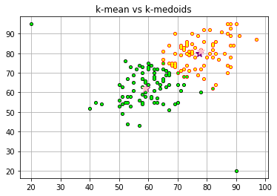

K-Medoid Score:96.1832251428574

K-Means Score:97.74999556310135

9

K-Mean Centroids: [[77.44, 80.05333333333333], [59.09090909090909, 62.15584415584416]]

K-Medoid Medoid[[60, 64], [78, 82]]

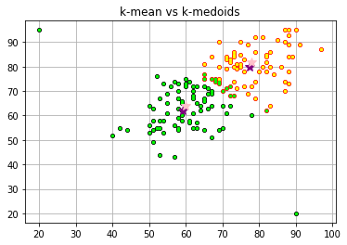

K-Medoid Score:94.68524668497246

K-Means Score:97.74999556310135

10

K-Mean Centroids: [[59.53086419753087, 62.641975308641975], [77.97183098591549, 80.50704225352112]]

K-Medoid Medoid[[59, 62], [78, 81]]



K-Medoid Score:97.04198399650362

K-Means Score:97.04198399650362